Remote Site Incubator (RSI) Project

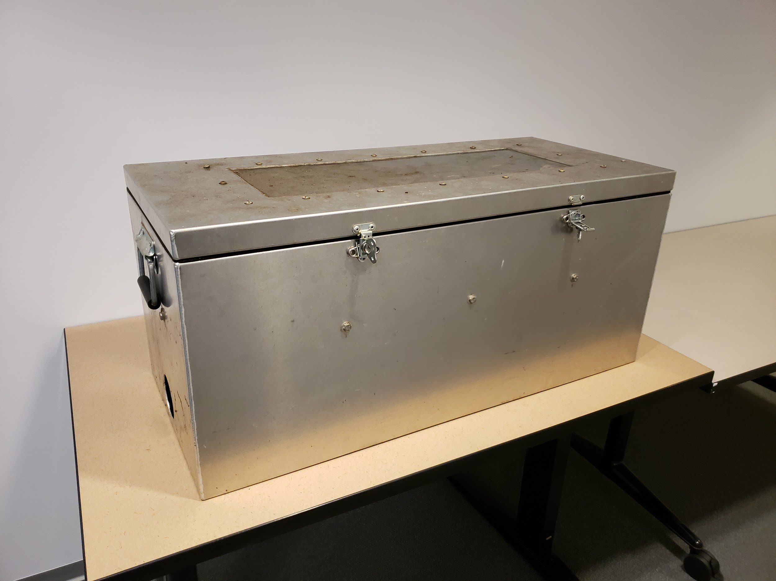

B EE 498 Independent Study

12/09/2019

Mike Miller

Contents

Abstract 3

Project Progress 3

Sensor Systems 3

Data Acquisition 4

Power System 4

# 

# **Abstract**

This project, under the direction of Dr. Jeff Jensen, is tasked with measuring prefered hatching conditions and accurate counts of salmon fry that pass out of an incubation chamber. The goal of this project is to reduce the time and effort required to gather this data. The scope of this project falls into 3 main areas, fish counting sensor development, data acquisition and transmission, and remote power grid development.

# **Project Progress**

Fish counting sensor development:

The fish counting sensor prototype is completed. It uses an optical loop and schmitt trigger to provide an interrupt signal to a microcontroller. Upon change of signal state in the optical loop, the counting method is run. The counting method keeps track of how many times the optical loop has been blocked as well as de-bounces the optical loop signal so it does not detect noise as fish. Currently we have one working sensor prototype as seen in figure 1.1.

**Figure 1.1:**

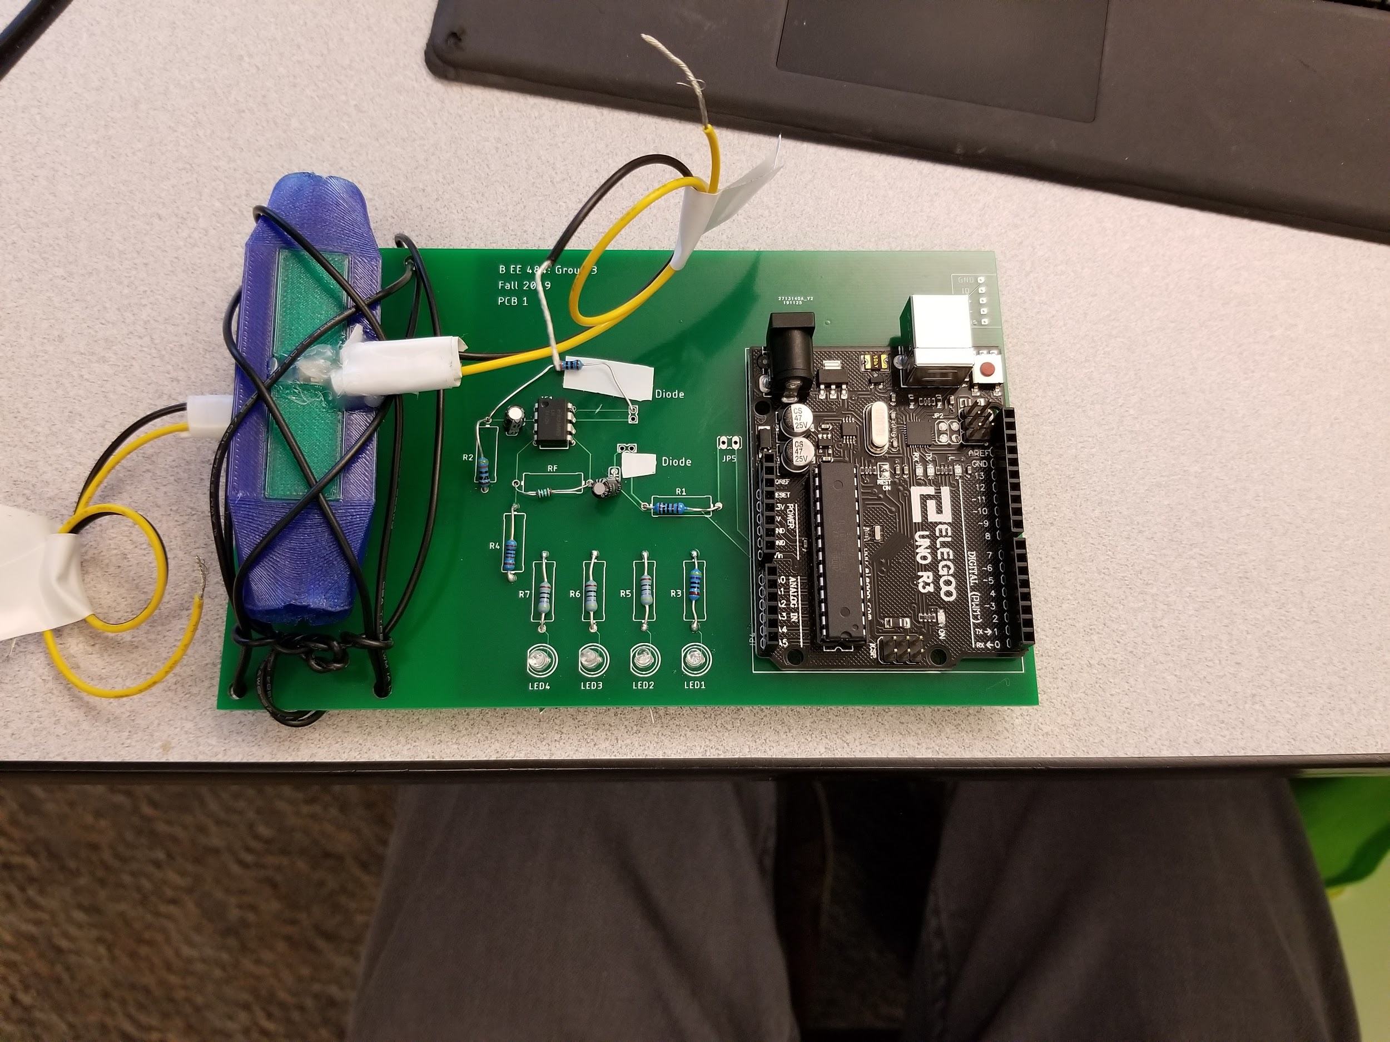

*Future work for sensor development:*

This sensor is not ready for deployment at this point. It needs to be expanded into an array of sensors to help with accuracy and flow rate for the fish through the sensor. The idea is to use enough sensors to keep the rate of flow equal from when the fish leave the incubation box to when they enter the stream. Additionally the power draw of this system when this is expanded into an array still needs to be measured.

Data Acquisition and Transfer:

The data acquisition of this project incorporates several kinds of sensors. It includes temperature, water flow rate, pH, turbidity, and the fish counting sensor. Most of these sensors have been tested, measured for power draw and implemented. Data acquisition is done with an Arduino Mega microcontroller. The data collected is currently being stored on an SD card and manually taken to a computer for analysis.

*Future work for Data acquisition:*

The majority of sensors to be used have been tested and measured for power draw. The ones that are not yet implemented are pH and turbidity sensors. Once these are tested and measured we can start to develop sensor calculation and measurement schemes to get power and energy consumption for the entire system.

Power system:

The power system for this project has two parts. One when the sensor network has access to the AC grid and another when AC power access is unavailable. The AC power component has been solved, all power from AC can come through the microcontroller and energy requirements will only affect the backup power system.

*Future work for Power system:*

Since the AC system has a power supply, a battery backup system needs to be designed in order to be able to take measurements in the event of a power outage. This battery backup system will be similar to the battery system for the remote solar powered DC microgrid. The Solar powered system still needs to complete power and energy profiles for all sensors before decisions can be made about how big of a battery is needed. A 100W solar panel will provide enough charging energy to supply the system for several days without the need to charge.